Name: _____________________________ Date: ________________

**Dilation Constructions**

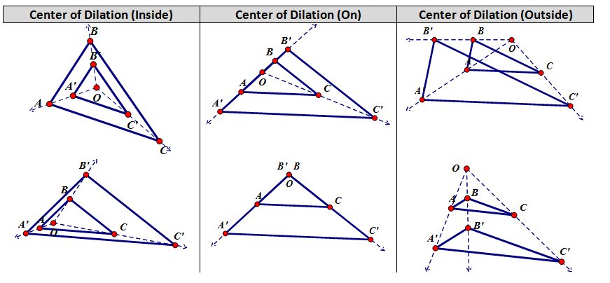

1. Using a compass and a straightedge, dilate the given triangle by a scale factor of 2 with the center of dilation at Point P.

P

1. Dilate Triangle QRS by a scale factor of 3 with the center of dilation Point X.

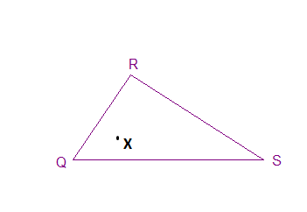

1. Dilate Quadrilateral ABCD by a scale factor of 2 with the center of dilation at Point A.

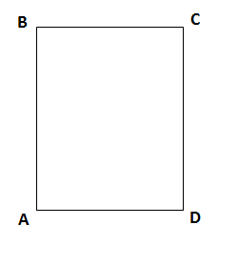

1. Dilate Triangle ABC by a scale factor of ½ with the center of dilation at Point N.

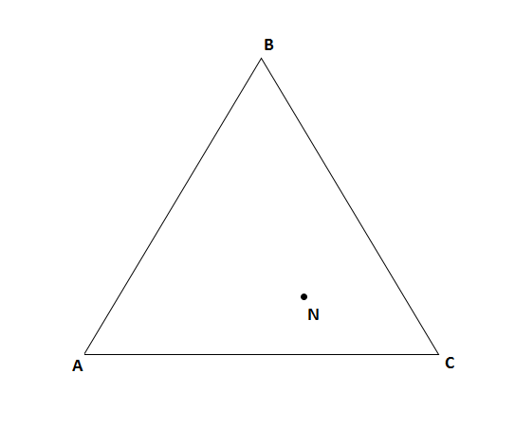

1. Dilate the given triangle by a scale factor of -2 with the center of dilation at A.

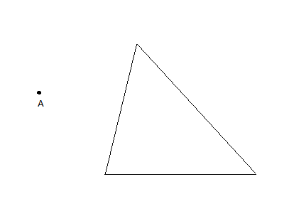

1. Dilate the given line segment by a scale factor of  with the center of dilation at A.

A